# PROJECT DESIGN PHASE-I

Solution Architecture

|  |  |
| --- | --- |
| **DATE** | 7 OCTOBER 2022 |
| **Team ID** | **PNT2022TMID27338** |
| **Project Name** | Project – Natural Disaster Intensity Analysis and Classification Using Artificial Intelligence |
| **Maximum Marks** | 4 Marks |

# Solution Architecture:

Solution architecture is a complex process – with many sub-processes – that bridges the gap between business problems and technology solutions. Its goals are to:

* Find the best tech solution to solve existing business problems.
* Describe the structure, characteristics, behavior, and other aspects of the software to project stakeholders.
* Define features, development phases, and solution requirements.
* Provide specifications according to which the solution is defined, managed, and delivered.

**Example - Solution Architecture Diagram:**

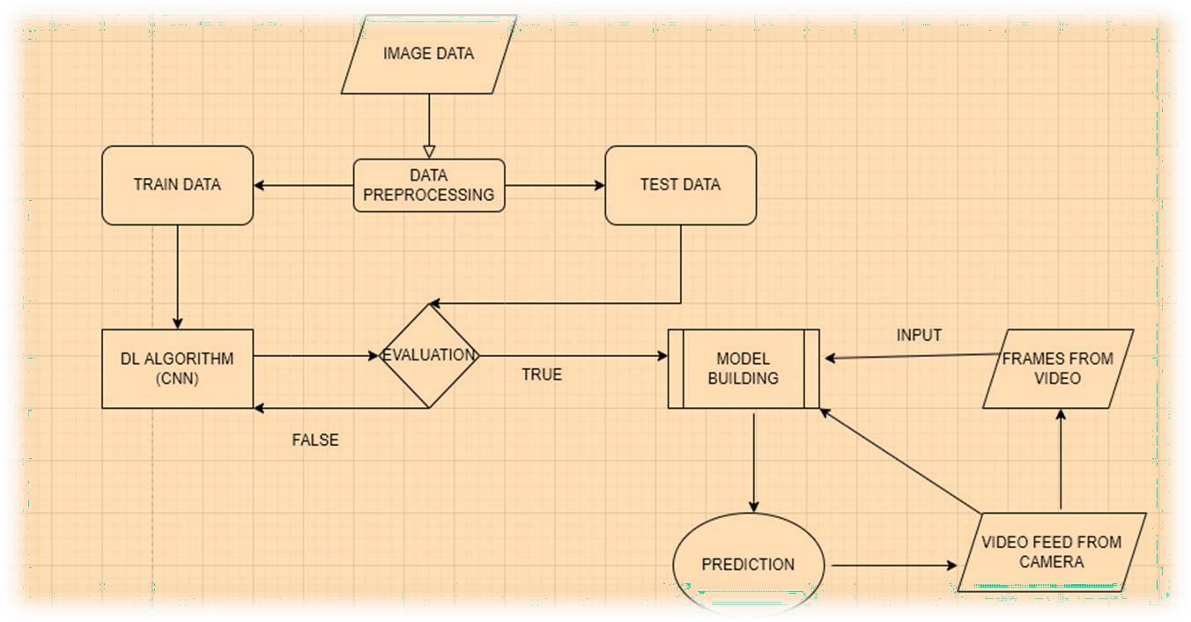

**Fig 1. Architecture and Flow Diagram to classify the natural disaster using Deep Learning Algorithms**